GP Presentation

Skill: Evaluation

Challenge: Believes about food

Germany’s National Dish: Sauerbraten

Background of the country and food:

Germany was once made up of many small states until it became one country in 1871. After World War I, Germany lost its empire, and later, Adolf Hitler came to power, leading to World War II, which caused great destruction. After the war, the country was divided into East Germany and West Germany. In 1990, the two parts joined together again to form the modern Germany, which is now a strong and important country in Europe. After reunification in 1990, Germany grew into a modern, and very powerful country. It became one of the leaders of the European Union, helping other countries work together in peace and trade. Today, Germany is respected around the world as a country that learned from its difficult past and works hard to build a better future.

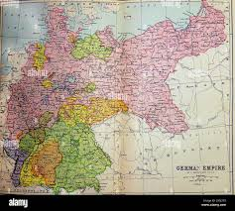

What is the belief about Germany about their national dish?

In region of Germany, many people consider **Sauerbraten** their signature dish. It’s a pot roast, usually made with beef, that is marinated for several days in vinegar, water, onions, and spices before being slow-cooked. This gives it a unique sweet-and-sour flavor. Traditionally, it’s served with red cabbage and potato dumplings. People in the Rhineland take pride in this dish, and some even view it as the closest thing to a “national dish” for their area. It’s part of their food identity and a recipe passed down through families for generations.

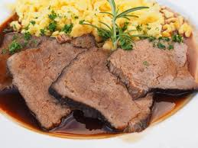

How is sauerbraten valued in Germany?

Sauerbraten is one of the most traditional and well-known dishes in Germany. It is often called the national dish because of its long history and cultural importance. The word “Sauerbraten” means “sour roast,” and it describes how the meat is prepared. This dish is made by marinating beef in vinegar, water, and spices for several days before cooking.

The origin of sauerbraten goes back many centuries. Some believe it was first created by the Romans, who used vinegar to preserve meat. Over time, German regions adopted the method and developed their own styles. By the Middle Ages, sauerbraten had become popular across different parts of Germany, especially in the Rhineland and Bavaria.

Sauerbraten is not just food; it represents tradition and family gatherings. In the past, families often cooked sauerbraten on Sundays or during holidays. The long marination process meant it was a meal prepared with patience and care. Many people remember eating it at their grandparents’ homes, which makes it a dish full of nostalgia.

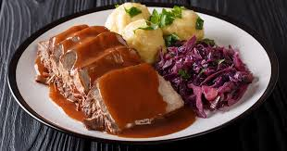

How does the food represent the country?

Sauerbraten represents Germany in a very clear way because it shows both the country’s history and its traditions. The dish takes time, care, and patience to prepare, which reflects the German value of doing things carefully and with discipline. It also shows how German cooking often combines strong, rich flavors like sour, savory, and sometimes sweet.

Each region in Germany has its own version of sauerbraten, which represents the country’s diversity. Germany is not just one single culture—it is made up of many regions with their own customs, dialects, and foods. Sauerbraten changes from the Rhineland to Bavaria to Swabia, and that variety reflects the character of the whole nation.

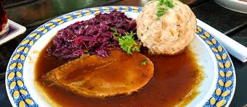

The dish also represents family life in Germany. Traditionally, it was made for Sunday dinners or holidays when everyone gathered around the table. This shows how food is connected with family and togetherness in German culture.